**Talk Halls -A room based realtime chatting website**

**Owner: Vedula Visweswar Sai Vignesh**

**LinkedIn:** <https://www.linkedin.com/in/vedula-visweswar-sai-vignesh-5184251bb>

**Website Link:** <http://13.49.230.34:3000/signUp.html> (currently we don't have a domain, so accessing it through the IP address.)

**Deployed on:** AWS cloud EC2.

**Technologies used :** Node.js, JavaScript, Express, Socket.io, html, CSS, Firebase [Authentication, Firestore], AWS EC2.

**Website Overview:** 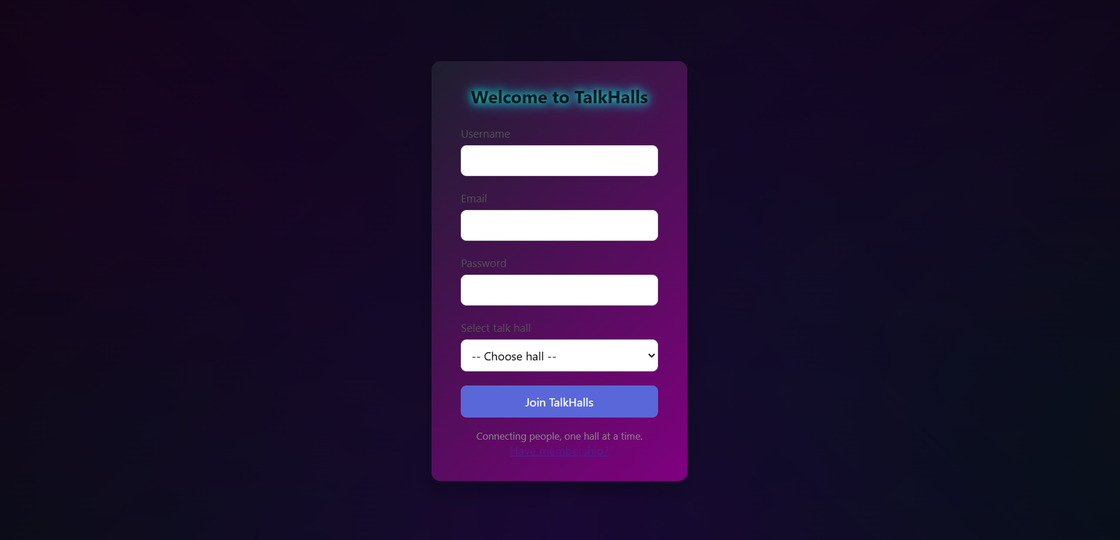

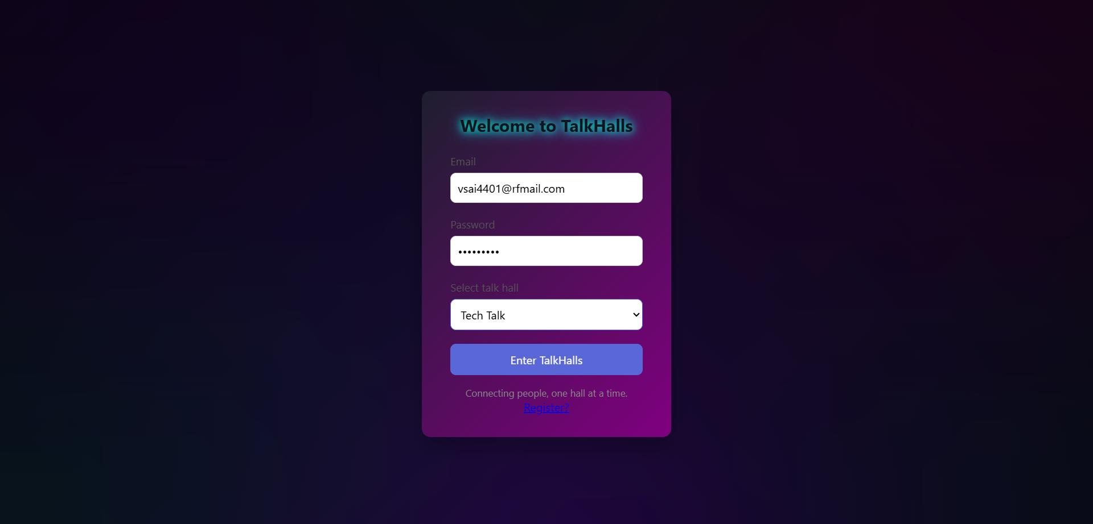

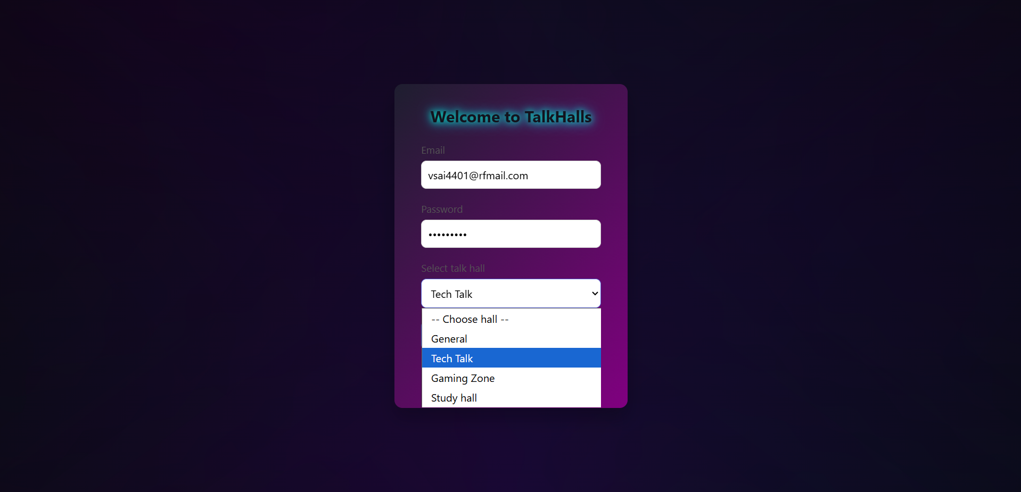

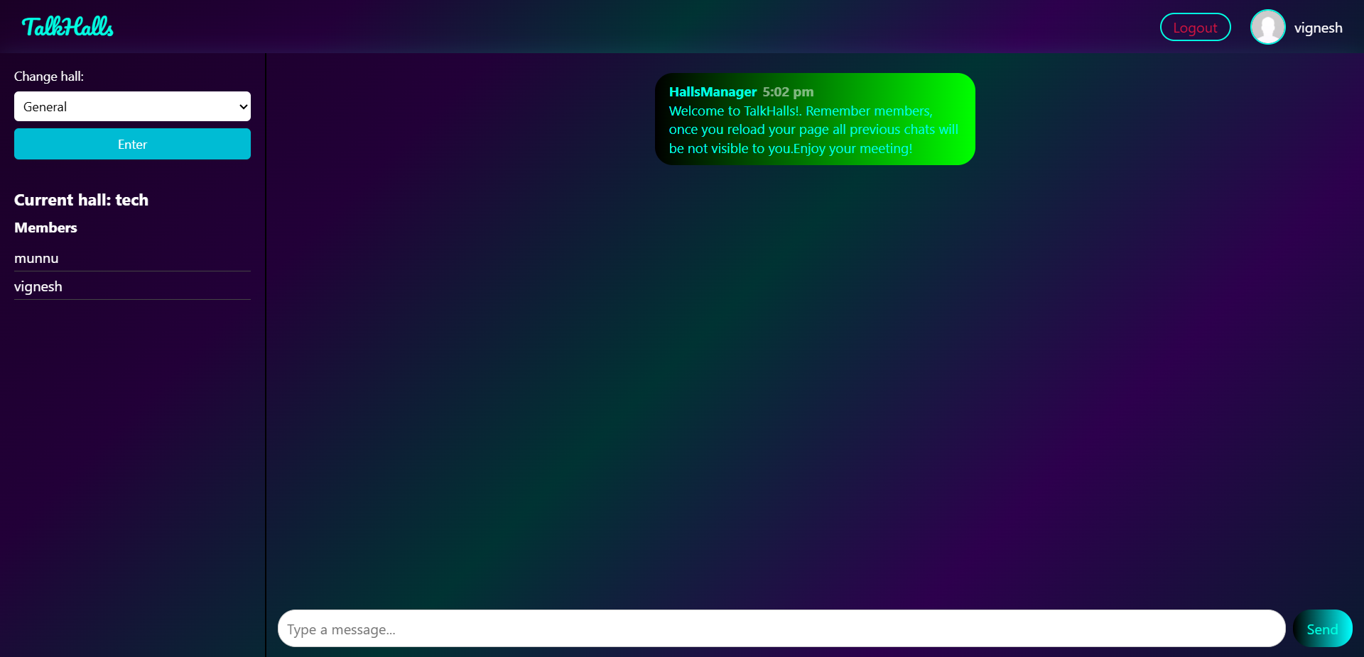

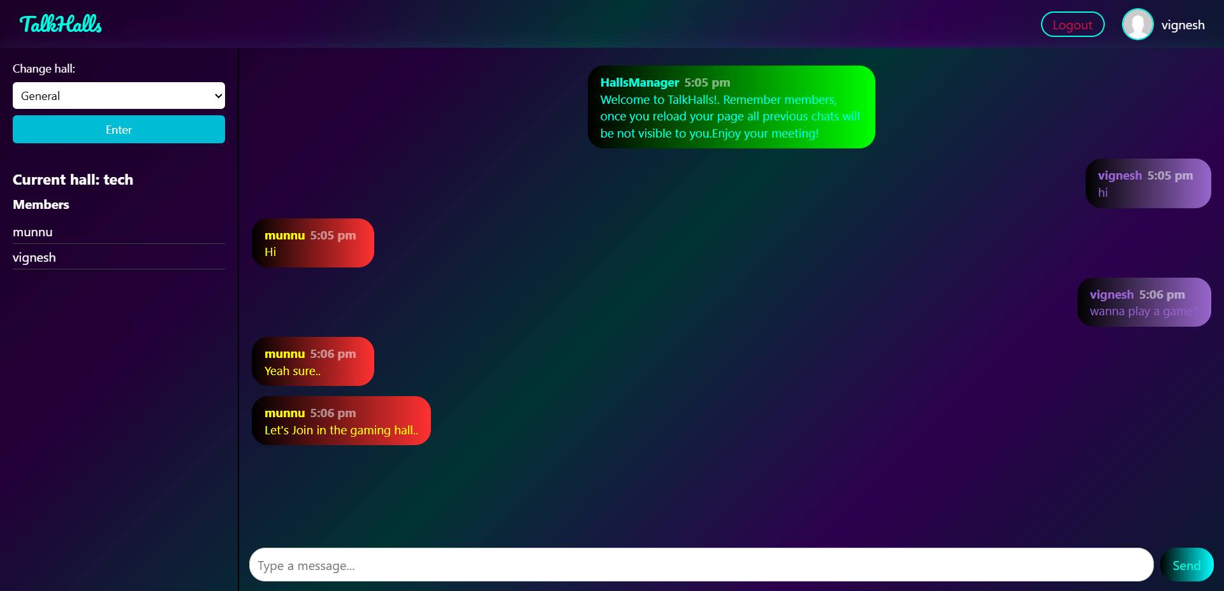

**Github link:** <https://github.com/Vignesh11011/TalkHalls-chat-app>

**Firebase Authentication and datastore:**

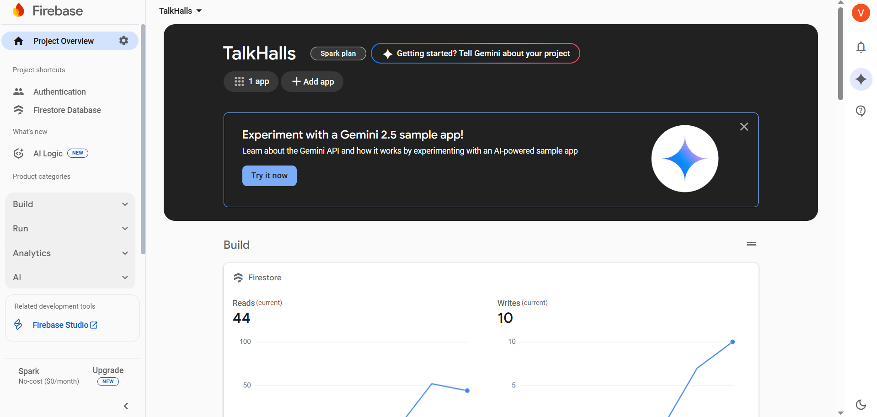

**Note:** Users' authentication details are stored in the authentication section of the project, A user can register using his email and password and keep a username for themselves.

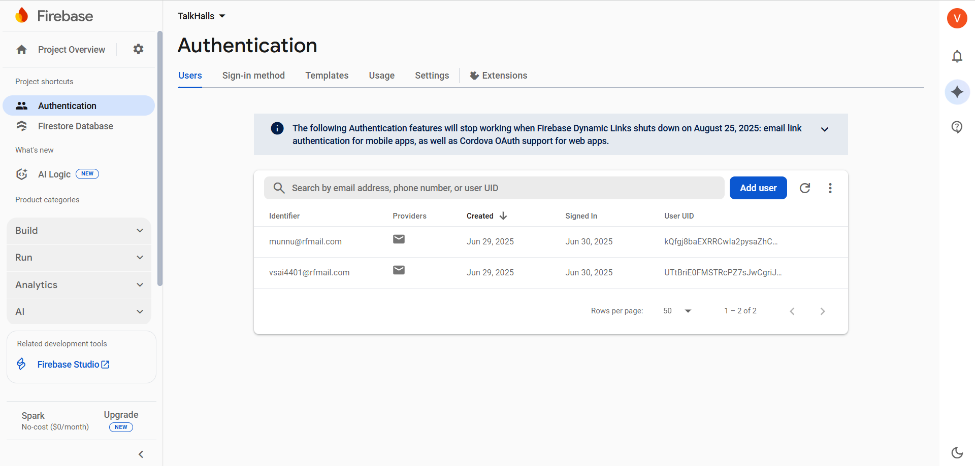

**Firestore:**

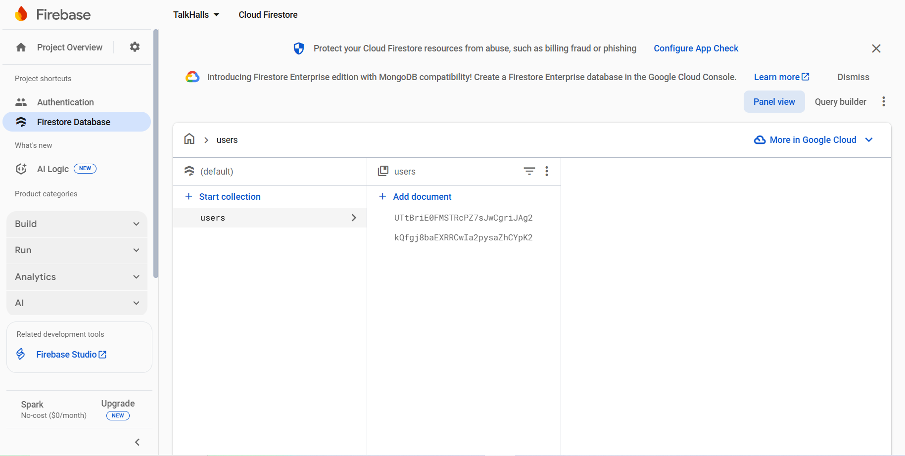

User data is stored as documents under users collection.(Like the dummy uids provided above ),user data will be in the format of json objects(key-value pairs).

**Note: AWS EC2 is used for hosting the webpage as some information might be confidential I am not reveling them.**